### Three Custom-Designed Prompts

**Prompt 1: Precise Fact Extraction**

* **Query:** "What is the maximum out-of-pocket expense for an individual under this policy?"
* **Purpose:** This prompt evaluates the system's capacity to:
  + Retrieve specific factual details from insurance policies.
  + Interpret specialized terminology such as "out-of-pocket expense."
  + Deliver a succinct answer supported by relevant citations.

**Input Screenshot**

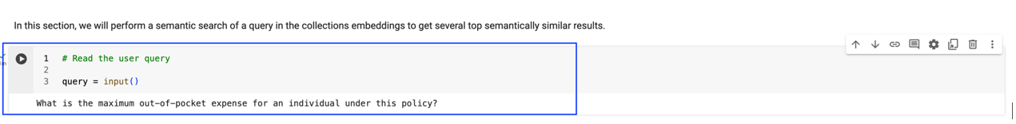

Top 3 results from semantic search

Top 3 results from generation layer

**Final Output**

**Prompt 2: Coverage Analysis**

* **Query:** "Does this policy cover pre-existing conditions? If so, are there any limitations?"
* **Purpose:** This prompt assesses the system's ability to:
  + Comprehend and address more complex inquiries related to policy coverage.
  + Effectively search through potentially multiple document sections to gather relevant data.
  + Provide a well-structured response that addresses both the question and any outlined limitations.

**Input Screenshot**

Top 3 results from semantic search

Top 3 results from generation layer

**Final Output**

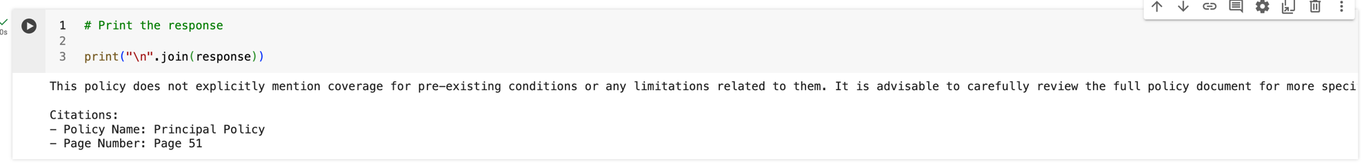

**Prompt 3: Evaluating Ambiguous Queries**

* **Query:** "Is this a good insurance plan?"
* **Purpose:** This prompt tests Mr. HelpMate AI's approach to subjective or open-ended questions.
  + Ideally, the system would recognize the subjective nature of this question and clarify that determining the plan’s value requires specific user needs.
  + An optimal response would explain its limitations in assessing the "goodness" of a plan but offer assistance in identifying factors that may help in making a more informed evaluation.

**Input Screenshot**

Top 3 results from semantic search

Top 3 results from generation layer

**Final Output**

